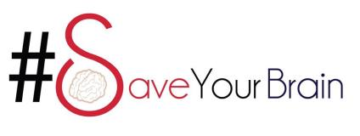
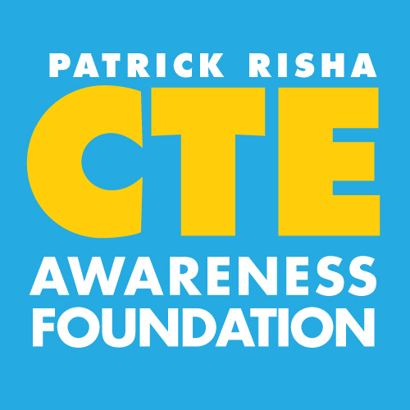

Dear Colleague,
Many families in this country are sadly dealing with the loss of a loved one as a result of CTE (Chronic Traumatic Encephalopathy). In most cases the families are totally unaware that the death is associated with CTE because it is a relatively new discovery in science and can only be clearly diagnosed post-mortem. The symptoms for CTE (irrational behavior, suicidality, drug addiction, and anger issues) also do not present themselves until many years or decades after the start of the disease. CTE is believed to be caused by repeated blows to the head or body. Contact sports, combat duty, and domestic abuse are believed to be the main factors contributing to the start of CTE in the brain. Many people have never heard of CTE. And because it is a progressive and degenerative disease that destroys the brain slowly, the symptoms of CTE may be linked to exposures long forgotten.
In your profession you are faced many times with families that are grieving over a suicide or drug over-dose and the negative implications and shock add to the horrible circumstance. You play a very vital role in many of the cases by being able to possibly give these families a medical reason for their loss. You play a vital role in giving the family much needed answers.
We are seeking brain donations for autopsy of people who played in collision type sports, had military combat duty, or were victims of domestic abuse. If you are presented with a case of suicide, drug over-dose, or reckless act, we are asking you to please give the next-of-kin one of the enclosed pamphlets. There are no costs to you for this study and identification of donors is confidential. Autopsies of the brain may provide families with critical information they may never have considered and allow them to find understanding from the tragedy while furthering science.
The National Institutes of Health (NIH) and the U.S. Department of Veterans Affairs (VA) are now funding brain banks at the Bedford VA Medical Center in Massachusetts under the direction of Dr. Ann McKee to acquire, process, and distribute brains of athletes and veterans at risk for or with a history of CTE, TBI, ALS, and PTSD. These are scientific endeavors to seek truth and help protect future generations.
We would like to send your practice a few hundred of these pamphlets for distribution by your field staff to effected families. In doing so your program may be able to aid in awareness and research and ultimately fewer deaths. You play a vital role in making that happen. For more brochures please contact the Patrick Risha CTE Awareness Foundation, StopCTE.org, 215-348-8308, contact@stopcte.org.

