Briefing on Understanding and Minimizing Sports-Related Brain Injuries
Thursday, September 14th, 2017

Speakers:

Congressman Bill Pascrell (D-NJ) - Chairman of the Congressional Brain Injury Task Force
Karen and Doug Zegel - President and Executive Board, The Patrick Risha CTE Awareness Foundation
Ann McKee, MD - Professor of Neurology & Pathology, Director, Neuropathology Core, Boston University
Noel Heiks - CEO, MVTRAK

Summary:

On Thursday, September 14th, the American Brain Coalition, the American Academy of Neurology, and the Patrick Risha CTE Awareness Foundation partnered with the Congressional Neuroscience Caucus and Congressional Brain Injury Task Force to host a briefing on “Understanding and Minimizing Sports-Related Brain Injuries.” The presentation explored our current understanding of sports-related injuries, and the research efforts that are giving us a deeper understanding of how to treat, and even prevent, a condition known as chronic traumatic encephalopathy or CTE.

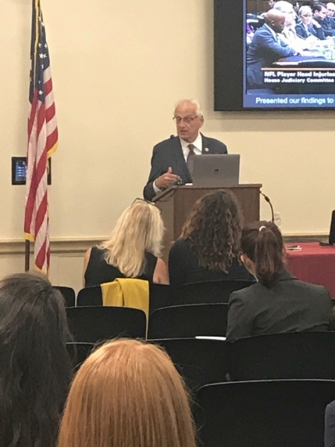
Congressman Bill Pascrell (D-NJ), co-chair of the Congressional Brain Injury Caucus, kicked off the briefing by sharing why he has become so passionate about the issue. Congressman Pascrell spoke of when he learned of the tragic death of Montclair High School’s Ryne Dougherty who died after an impact during a junior varsity football game. He had not been given enough time to recover after suffering from a concussion in practice weeks before. According to Congressman Pascrell, the Center for Disease Control estimates that 1.4 million people sustain a traumatic brain injury each year, and an estimated 3.2 million Americans are living with long-term disabilities because of brain injury. Millions more are suffering from the residual effects of brain injuries that are less severe, but still dangerous. Congressman Pascrell founded the bipartisan Congressional Brain Injury Task Force to increase awareness of brain injury in the United States and to support research initiatives for rehabilitation and potential cures.

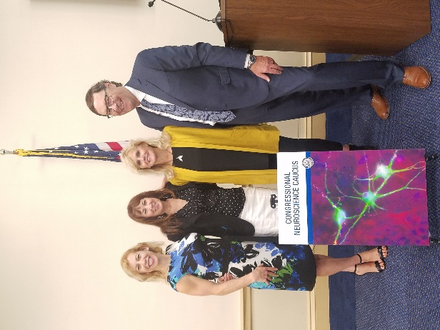
Karen and Doug Zegel, President of the Patrick Risha CTE Awareness Foundation and a board member respectively, shared their own family’s experience battling with brain injury. Their story was about Patrick who had played football his whole life and after years of experiencing CTE symptoms committed suicide. Since then, Mrs. Zegel has devoted her life to CTE and traumatic brain injury awareness through her foundation. The mission of the Patrick Risha CTE Awareness Foundation is to provide parents of school age children with information about the dangers of sports associated with head trauma. Karen shared that she felt that parents deserved to have risk information about head injuries in sports, information she did not have. While football players are certainly one of the most at-risk groups, the risk of CTE is high in a number of other sports, such as hockey, lacrosse, soccer, and even cheerleading. Mrs. Zegel relayed her worry that sports-related injuries may be connected to other health issues including suicide and drug addiction.

Dr. Ann McKee, a Professor of Neurology & Pathology at Boston University and a renowned expert on sports-related brain injuries, spoke of the scientific journey of discovering the connection between sport-related head impact and CTE and the continued effort to establish a way to identify the disease in living people. Dr. McKee and colleagues recently published a post-mortem study showing that 110 out of 111 former NFL players had suffered from CTE. Similarly, 48 out of 53 former college football athletes were found to have CTE. She showed face after face of people whose brain had been donated to her bank. For years these players and their families suffered though symptoms that included stark behavioral changes, increased impulsivity, degenerating cognitive abilities, and in many cases like Karen Zegel’s son, suicide. Dr. McKee noted that CTE has been found in many veterans as well, and that these same symptoms are common for those injured by explosions.

Dr. McKee’s work has moved the needle on sports-related brain injuries, but she conveyed that after nine years, much more work is still needed. She emphasized that detection is still far from perfect, and that the exact causes of CTE still need to be precisely identified. She explained that brain inflammation has been shown to be a predictor but the research is far from complete. Image scans of the brain and white matter detection have also been found to help determine the extent of damage to the brain, but more accessible solutions are still needed. She expressed hope, relaying that the she believed that the disease could be prevented and probably treated. She urged staff in the room to share with members of Congress that more funding specifically dedicated to brain injury is needed. She explained that with current funding, only 10 grants have been given to CTE research compared to the 3,500 grants for Alzheimer’s disease, and yet, traumatic brain injury and CTE affects at least as many people, including children, young athletes and young military service members.

Noel Heiks, CEO of MVTRAK, shared her company’s efforts to generate meaningful data about head impacts. MVTRAK designs wearable sports monitoring technologies that provide athletes who play contact sports with feedback on concussion risk. The company was founded by Cindy Parlow Cone, a two-time Olympic gold medalist and World Cup Champion who retired at 24 due to post-concussion syndrome. Ms. Heiks showed a video of Cindy sharing her story and how persistent symptoms still impact her to this day. Ms. Heiks also shared her own experience helping her husband rehabilitate from a “moderate” brain injury after a car crash left him unable to talk and feed himself. She noted that it is estimated that 85% of concussions or brain injuries go undetected and undiagnosed and yet, even what is consider minor head impacts can have devastating long term effects. She attributed this to the lack of accurate data, a problem that MVTRAK is trying to solve. Ms. Heiks directed the attention of the audience to the small device she wore in and around her ear, a sensor called Tachta which measures magnitude, direction, and frequency of impacts. She explained that Tachta is helping MVTRAK develop databases of information to drive a better understanding of injury risk, recovery, and rehabilitation.

Together, the speakers relayed that steps could be taken to remedy the pervasive problem of brain injury and urged Congress and the general public to give more attention to the issue. This event was one of several briefings hosted by the Congressional Neuroscience Caucus. The Congressional Neuroscience Caucus seeks to raise awareness about the millions of Americans afflicted with neurological disorders or mental illnesses. The Caucus is co-chaired by Reps. Earl Blumenauer (D-OR) and Cathy McMorris Rodgers (R-WA). Attendees consisted of staff from Hill offices, in addition to federal agency officials and ABC members.

